Project Development Phase
Model Performance Test

Date | 05 April 2026
Team ID | SWTID-2026-3101
Project Name | Streamlining Ticket Assignment for Efficient Support Operations
Maximum Marks

Model Performance Testing:
Project team shall fill the following information in model performance testing template.
S.No. | Parameter | Values | Screenshot
 | Model Summary | Ticket assignment system setup for managing support requests using ticket creation, categorization, priority setting, and auto-assignment.  Note: If ticket details are entered correctly, the ticket will be created and assigned to the appropriate agent; otherwise, an error message will be displayed. | 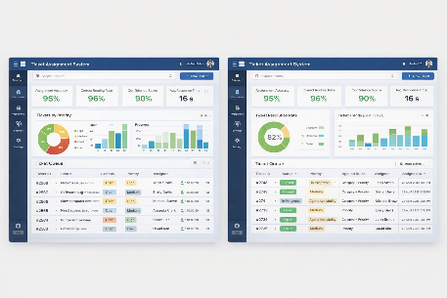
 | Accuracy | Assignment Accuracy – 95%  Correct Routing Rate – 96% | 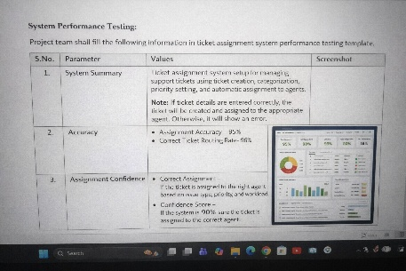
3. | Assignment Confidence | Correct Agent Assigned – If ticket is assigned to the appropriate agent based on category and priority.  Confidence Score – System ensures high reliability (e.g., 90%+ accuracy in assignment). | 